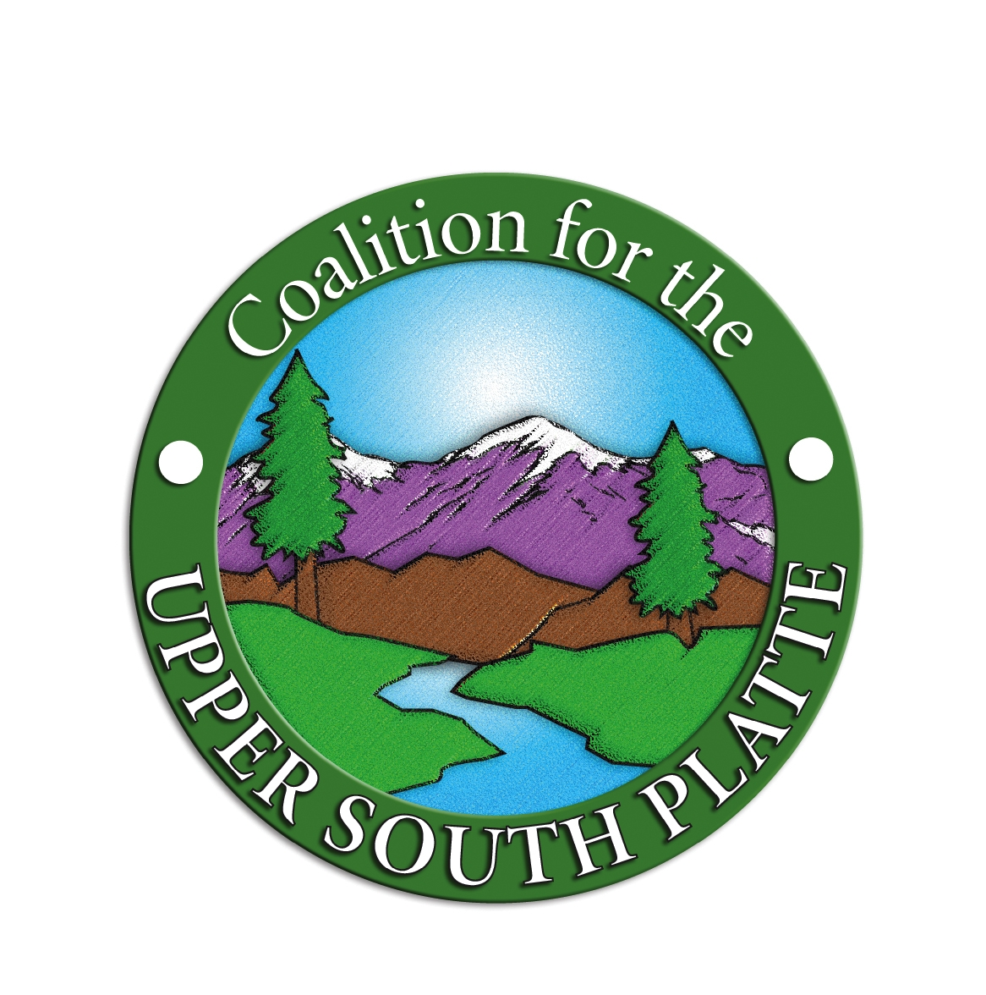
PLEASE PRINT CLEARLY

ASSUMPTION OF RISK, RELEASE FROM

LIABILITY AND AGREEMENT

( ) Mr. ( ) Ms. Last Name: First Name:
Spouse: New Volunteer YES NO
Street Address: New Address YES NO
City, State, Zip:
Home Phone: E-Mail:
Date of Birth: ________________________________ SS#: _________________________________________
In case of emergency, please contact:
NAME:
RELATION:
PHONE: (home) (work)

The following information may be needed by any hospital or medical practitioner not having access to the Volunteer/Participant’s medical history:

Allergies (Medicine, food, etc):
Medications being taken:
Date of last tetanus shot:
Physical impairments:
Other:

- I acknowledge that I have voluntarily applied to participate in restoration and other activities at various locations with the Coalition for the Upper South Platte (CUSP).

- As consideration for being permitted to participate in these activities and use CUSP tools and facilities, I hereby agree that I, my assignees, my heirs, distributes, guardians, and legal representatives will not make a claim against, sue, or attach the property of CUSP, or the suppliers of any of the tools or equipment I will use in these activities, for injury or damage resulting from the negligence or other acts, howsoever caused, by any employee, agent, contractor of or other participant in CUSP activities.

- I hereby release CUSP from all actions, claims, and demands that I, my assignees, my heirs, distributes, guardians and legal representatives now have or may hereafter have for injury or damage resulting from my participation in CUSP activities.

- I hereby release and forever discharge CUSP from any claim whatsoever which arises or may hereafter arise on account of any first aid, treatment, or participation in CUSP activities.

☞ More on other side

- I understand that CUSP does not carry or maintain health or disability insurance coverage for any volunteer. EACH VOLUNTEER IS EXPECTED AND ENCOURAGED TO ARRIVE WITH HEALTH INSURANCE COVERAGE IN EFFECT.
- I expressly agree that this Release is intended to be as broad and inclusive as permitted by the laws of the State of Colorado, and that this Release shall be governed by and interpreted in accordance with the laws of the State of Colorado. I agree that if any clause or provision is ruled invalid by any court of competent jurisdiction, the invalidity of such clause or provision shall not otherwise affect the remaining provisions of this Release shall continue to be enforceable.
- I AM AWARE THAT FIRE RESTORATION, GREEN FOREST RESTORATION, TRAIL BUILDING, RIVER RESTORATION AND OTHER CUSP ACTIVITIES ARE HAZARDOUS. I AM VOLUNTARILY PARTICIPATING IN THE ACTIVITIES OF CUSP WITH THE KNOWLEDGE OF THE DANGER INVOLVED AND WITH THE KNOWLEDGE THAT MEDICAL FACILITIES MAY NOT BE AVAILABLE IN THE EVENT OF INJURY TO ME. I HEREBY AGREE TO ACCEPT ANY AND ALL RISKS OF INJURY AND DEATH, AND VERIFY THIS STATEMENT BY PLACING MY INITIALS HERE: __________
- If there is any violation of this agreement and CUSP is sued, or a claim is made against CUSP, I agree to indemnify CUSP and the others named in paragraph 2 and hold them harmless from any and all expense and liability. Such indemnity shall cover all reasonable expenses incurred by them, including but not limited to attorney fees.

AUTHORIZATION AND RELEASE
I hereby grant to the Coalition for the Upper South Platte (CUSP), its legal representatives, successors and assigns, irrevocable permission to take and to copyright, in its own name or otherwise, and re-use, publish and republish photographic portraits, pictures or similar images or likenesses (collectively, the “Pictures”) of me and my children and/or other minors for which I am legally responsible, including, without limitation, any other Pictures in which I or they may be included, in whole or in part, composite or distorted in character or form, without restriction as to changes or alterations, in conjunction with my own or fictitious name(s), or reproductions thereof in color or otherwise, made through any medium, and in any and all media now or hereafter known for illustration, promotion, art, editorial, advertising, trade, and any other purpose whatsoever. I also consent to the use of any published matter in connection therewith. The Pictures may be published in any manner, including advertising, periodicals, trade show exhibits and other promotional applications. Furthermore, I will hold harmless CUSP, its representatives, successors and assigns, from any liability arising from or in connection with the aforementioned Pictures.
I affirm that I am more than 18 years of age and that I am competent to sign this contract on my own behalf. I acknowledge that I have read the foregoing authorization and release and that I fully understand its contents.

-----------------------------------------------------------------------------------------------------------------------------------
(Please Print Name) (Date)
I HAVE CAREFULLY READ THIS ASSUMPTION OF RISK, RELEASE OF LIABILITY, AND RELEASE AGREEMENT AND I FULLY UNDERSTAND ITS CONTENTS. I AM AWARE THAT THIS IS A RELEASE OF LIABILITY AND A CONTRACT BETWEEN ME AND CUSP. I AM SIGNING THIS DOCUMENT OF MY OWN FREE WILL.

Executed at: , Colorado, on:
(work project location) (Date)
Date of Birth:
(Volunteer’s Signature)
* * * * * * * * * * * * * * * *
CUSP volunteers must be 16 years of age or older when the construction site is utilizing power tools/equipment. Parental signature is mandatory for volunteers under 18 years old.

(Parent/Legal Guardian’s Name- PLEASE PRINT) (Parent/Legal Guardian’s Signature)
( )_______________
(Phone Number)

